**Assignment 21.2:**

Implement the below blog at your end and send the complete documentation.

<https://drive.google.com/file/d/0B_Qjau8wv1KoUThzZ24tT1NsZGs/view?usp=sharing>

Aviation data analysis:

**Problem Statement 1**

Find out the top 5 most visited destinations.

val delayed_flights =sc.textFile("DelayedFlights.csv")

val mapping = delayed_flights.map(x => x.split(",")).map(x => (x(18),1)).filter(x =>x._1!=null).reduceByKey(_+_).map(x => (x._2,x._1)).sortByKey(false).map(x => (x._2,x._1)).take(5)





**Problem Statement 2**

Which month has seen the most number of cancellations due to bad weather?

val delayed_flights = sc.textFile("DelayedFlights.csv")

val canceled = delayed_flights.map(x => x.split(",")).filter(x => ((x(22).equals("1"))&&(x(23).equals("B")))).map(x => (x(2),1)).reduceByKey(_+_).map(x =>(x._2,x._1)).sortByKey(false).map(x => (x._2,x._1)).take(1)



**Problem Statement 3**

Top ten origins with the highest AVG departure delay.

val header = delayed_flights.first()

val delayed_flight = delayed_flights.filter(x => x != header)

val avg = delayed_flight.map(x => x.split(",")).map(x => (x(17),x(16).toDouble)).mapValues((_, 1)).reduceByKey((x, y) => (x._1 + y._1, x._2 + y._2)).mapValues{ case (sum, count) => (1.0 * sum)/count}.map(x => (x._2,x._1)).sortByKey(false).map(x => (x._2,x._1)).take(10)



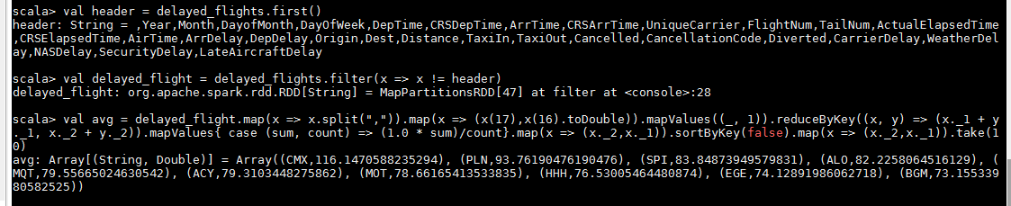

**Problem Statement 4:**

Which route (origin & destination) has seen the maximum diversion?

val delayed_flights = sc.textFile("DelayedFlights.csv")

val diversion = delayed_flights.map(x => x.split(",")).filter(x => ((x(24).equals("1")))).map(x =>

((x(17)+","+x(18)),1)).reduceByKey(_+_).map(x => (x._2,x._1)).sortByKey(false).map(x =>

(x._2,x._1)).take(10).foreach(println)

